**A. LPVI Process**

The implementation of the LPVI method unfolds progressively according to the forecasting horizon: in the day-ahead stage, high-accuracy forecasts enable hourly optimization; in the monthly stage, several representative days are selected, each divided into a limited number of optimization intervals, with the results scaled to cover the entire month; in the annual stage, the granularity is further reduced through the representative-day approach, using fewer intervals to characterize the year. The combination of these three stages ultimately constitutes the complete annual optimization model. The framework diagram is shown in Fig. 1.

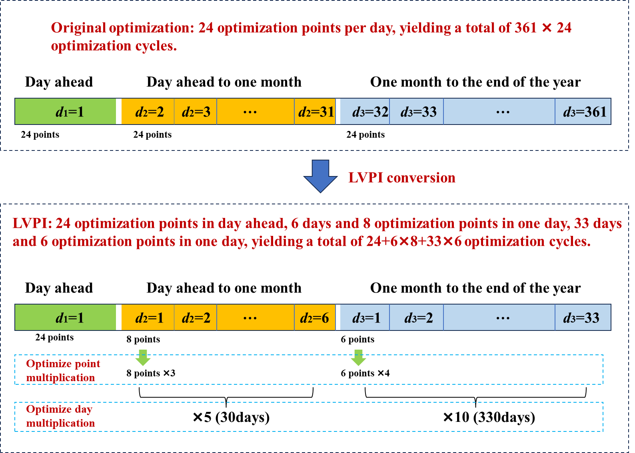

1. **LVPI framework diagram**

Assuming a year consists of 361 days and 24 hours of optimization per day, traditional optimization would require 361 × 24 = 8,664 optimization cycles. This becomes computationally intensive for optimization models involving binary (0–1) variables. Furthermore, due to prediction errors inherent in long-term annual optimization, such fine-grained optimization is often unnecessary.

The core idea of LVPI is to focus on fine-grained optimization in the short term while gradually reducing granularity as the optimization horizon extends. Specifically, a 24-hour optimization conducted the day before provides a detailed scheduling reference for the upcoming day. Then, six optimization days are selected within a one-month horizon, with each optimization spanning eight hours. For the remaining 11 months of the year, three optimization days are chosen per month, with each optimization spanning six hours. Under this scheme, the total number of optimization cycles becomes 24 + 6 × 8 + 33 × 6 = 270, significantly reducing computational complexity.

However, due to the variable optimization granularity, the annual total optimization objectives must be aligned with the original target granularity. To achieve this, particle size is optimized by a factor of 3 and the number of optimization days by a factor of 5; similarly, the annual particle size is optimized by a factor of 4 and the number of optimization days by a factor of 10 each month. This adjustment ensures that the total optimization objective remains of the same order of magnitude as the 8,664 cycles required by traditional optimization.

(1) Day-ahead optimization

* + In the day-ahead stage, since the prediction accuracy is high, a fine-grained optimization approach is employed.
  + The day is divided into 24 optimization points, corresponding to hourly optimization decisions.

(2) Optimization from the day-ahead to one month

* + As the prediction period extends beyond the next day to a month, uncertainties increase, making hourly optimization less practical. Instead, a representative-day approach is adopted.
  + Six representative days are selected to capture the month’s operational characteristics, with each representative day corresponding to five actual operating days.
  + Each representative day undergoes optimization at eight time points.
  + Consequently, the optimization results for this stage must be scaled by a factor of ×3 (for eight time points per day) ×5 (for five actual days per representative day) to cover the entire period adequately.

(3) Optimization from one month to the end of the year

* + As the prediction horizon extends further, the optimization granularity is further coarsened to reduce computational burden while maintaining representativeness.
  + Thirty-three representative days are selected to represent the remaining 330 days, with each representative day corresponding to ten actual operating days.
  + Each representative day undergoes optimization at six time points.
  + The optimization results for this stage must be scaled by a factor of ×10 (for ten actual days per representative day) to generalize to the full annual period.

Firstly, symbols related to LPVI are introduced. Specifically, *d*1, *d*2, and *d*3 denote the indices of typical days for the following day, the next month, and the period from one month to the end of the year, respectively, with index ranges of 1, 6, and 33. Similarly, *t*1, *t*2, and *t*3 represent the optimization points for each typical day before the day, within one month, and from one month to one year, with index ranges of 24, 8, and 6, respectively. The process is shown in **Fig. 2**.

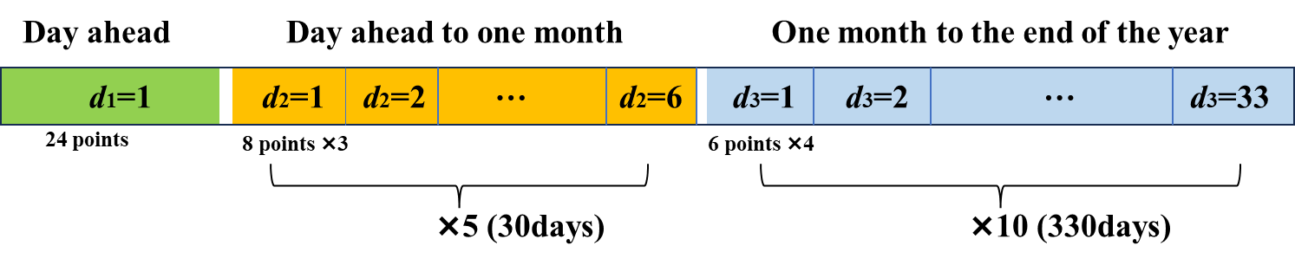

1. **Explanation of LPVI coordination mechanism.**

It is important to note that the particle size used in this study is chosen based on the selection of steel users as the research focus, given their relatively stable electricity consumption and steel product prices. For other types of users, clustering methods can be employed to determine the typical daily quantity and appropriate particle size for different periods. Users can apply this method for rolling optimization, where the total number of optimized days decreases by one with each rolling step until the entire year is optimized. However, this study focuses on the annual planning framework and does not elaborate on the specific rolling process.

**B. Case Data of PJM-5 System**



1. **The modified PJM 5-node system.**

The cost and performance data for generators G1-G5 are presented in **TABLE 1** and **TABLE 2**. Specifically, the fuel cost for coal-fired generators is set at 107.14 dollars per ton, while the fuel cost for gas-fired generators is 0.34 dollars per cubic meter. The equivalent emission factor (*ei*) of the wind generator is set to -0.2.

1. **Cost data of units G1-G5**

|  |  |  |  |
| --- | --- | --- | --- |
| Generator No. | Generator type | *a*(t/MW2)/(m3/MW2) | *b*(t/MW)/(m3/MW) |
| G1 | Coal-fired | 0.0007 | 0.2449 |
| G2 | Coal-fired | 0.0010 | 0.2656 |
| G3 | Gas-fired | 0.2998 | 107.0115 |
| G4 | Coal-fired | 0.0008 | 0.1952 |
| G5 | Coal-fired | 0.0008 | 0.2286 |

1. **Performance data of units G1-G5**

|  |  |  |  |
| --- | --- | --- | --- |
| Generator No. | *PG,*min/MW | *PG,*max/MW | *ei*/(tCO2/MWh) |
| G1 | 120 | 600 | 0.525 |
| G2 | 22 | 110 | 0.300 |
| G3 | 20 | 100 | 0.300 |
| G4 | 104 | 520 | 0.875 |
| G5 | 40 | 200 | 0.875 |

### C. Modified IEEE 118-Bus System

The IEEE 118-bus system is applied to demonstrate applicability of the proposed method to large systems. The modified system, as shown in **Fig. 4**, has 118 loads with 5 transferable load and 21 generators and consists of 118 buses, and 186 branches. The 5 transferable load electricity consumption curves are derived from the actual annual electricity consumption curves of five steel users and adjusted proportionally.



1. **The modified IEEE 118 system.**

In this section, RMCEFd represents the use of RMCEF as an incentive and calculates the daily carbon emission responsibility and fee for users (the proposed method). RMCEFt represents the carbon emission responsibility and carbon fee that users bear on an hourly basis, and is compared with the average carbon emission and carbon emission flow theory as the user-side carbon responsibility allocation method. The results are shown in **TABLE 3**.

1. **Comparison of carbon emissions under different carbon emission responsibility in modified IEEE 118 system.**

|  |  |  |  |  |  |
| --- | --- | --- | --- | --- | --- |
| incentive factors |  | carbon emissions (kt) | system carbon emission(kt) | total carbon fees (kilo dollars) | total net profit (million dollars) |
| RMCEFd | user1 | 62.80 | 2066.7(**—**) | 748.96 | 112.91 |
| user2 | 40.26 |
| user3 | 93.98 |
| user4 | 43.95 |
| user5 | 36.45 |
| RMCEFt | user1 | 63.36 | 2067.3(**+657**) | 850.64 | 112.61 |
| user2 | 40.57 |
| user3 | 94.77 |
| user4 | 44.29 |
| user5 | 36.71 |
| ACEF | user1 | 62.81 | 2067.8(**+1128**) | 613.74 | 113.25 |
| user2 | 40.15 |
| user3 | 92.65 |
| user4 | 43.42 |
| user5 | 36.45 |
| NCI | user1 | 42.09 | 2068.7(**+2028**) | 1496.30 | 103.72 |
| user2 | 42.48 |
| user3 | 157.88 |
| user4 | 56.96 |
| user5 | 40.51 |

The simulation results of 118 nodes are basically the same as those of 5 nodes. It can be seen that the method proposed in this article reduces the carbon emissions of the system the most, while the carbon emissions of the other three methods increased by 657kt, 1128kt, 2028kt compared to the proposed method. The comparison of the results between RMCEFd and RMCEFt demonstrates the superiority of the proposed daily allocation of carbon responsibility and payment of carbon fees, while the comparison with ACEF and NCI demonstrates the superiority of the proposed carbon emission allocation responsibility.

The difference is that the average carbon emission factor is used as the incentive factor for the user side. The carbon emission factor borne by the user is higher than that of the algorithm proposed in this paper, but the total carbon emissions of the system are reduced. This is because in the IEEE 118 system, the proportion of transferable loads is relatively small. After these 5 loads are transferred, the average carbon emission factor of the system changes, causing the fixed load carbon responsibility in the system to increase from 1506.9 kt to 1517.6 kt, further reducing the carbon responsibility borne by transferable loads, which also leads to inequity in the carbon market.

### D. Annual carbon price data

11.3512, 10.8650, 10.6891, 10.4438, 10.7600, 10.2960, 11.0142, 11.0349, 11.0349, 11.7443, 12.3059, 12.6591, 13.2472, 12.9561, 13.3891, 15.1462, 15.0250, 14.3970, 14.5581, 14.1014, 13.9906, 13.3980, 13.3906, 12.9310, 13.5369, 13.5147, 13.4911, 13.1586, 13.7615, 13.7142, 14.6541, 14.7827, 15.2837, 15.2866, 15.5216, 15.4847, 15.2083, 14.9172, 14.4118, 14.4406

The maximum and minimum carbon price coefficient sets to 1.6 and 0.6.

### E. Reformulation of the bi-level model

1. Upper level:

1) Variables obtained from lower level: 

2) Input parameters: , , , , , , , , , , , , , , , , , , .

3) Decision variables: , , , , , , , , , , , 

4) Passing variables to lower levels: , , 

The optimization is performed on a daily scale, with the annual plan from the optimization day to the end of the year considered in each daily optimization.

 (1)

 (2)

*CcarbonG* and *Cpe* shown in Eqs. (15) and (19).

The constraints of the upper-level optimization model are as follows.

(1) Line flow constraints:

 (3)

where *Jl* represents the set of load nodes connected to node *n*. *Il* represents the set of power generator nodes connected to node *n*. *k* represents any node connected to node *n*. *θl,t* and *θk,t* denote the voltage phase angles of nodes *i* and *k* at time *t*, respectively. *Xlk* is the reactance of the branch *lk*.  is the Lagrange multiplier, representing the marginal electricity price. , ,  are the decision variables, and  is the input parameter.

(2) Generator output constraints:

 (4)

 (5)

where ,  represent the minimum and maximum power output limits of the thermal power generator *i*.  represent the maximum power output limits for renewable energy generator *i*. , ,  are the input parameters.

(3) Line power constraint:

 (6)

where *ei* represents the carbon emission coefficient of the *i* th generator, *G* corresponds to the set of generators.  is the decision variable, so as the .

(4) Carbon emission constraints:

 (7)

 (8)

 (9)

 (10)

 (11)

where  denotes the initial carbon emissions obtained when the ISO clears the market at =, Although derived from the market clearing calculation, it is independent of the bi-level model and is therefore treated as an input parameter.

(5) Linear model transformation constraint:

In the above, Eqs. (1) involve dynamic carbon pricing and are piecewise linear functions. Since the independent variable *Ep* is negative when carbon allowances are sold externally, it need to be reformulated using the Big-M method. The reformulated equations are:

 (12)

 (13)

 (14)

 can be transformed into:

 (15)

 (16)

For , due to the existence of a term for minimizing carbon penalty in the objective function of this article, it can be equivalently relaxed as the following Equations:

 (17)

 (18)

 (19)

where *cpe* represents the carbon penalty, *cpe,s* represents the slack variable.

2. Lower level:

1) Variables obtained from upper level: , , 

2) Input parameters: , , , , , , , , , , .

3) Decision variables: , , , , , , , 

4) Passing variables to upper levels: 

The objective function of users is as follows:

 (20)

 (21)

 (22)

*CcarbonL,j* and *Cpe,j* can be seen in Eqs. (31) and (35).

The constraints of the lower-level optimization model are as follows:

(1) Load adjustment upper and lower limit constraints:

 (23)

(2) Total load adjustment constraints:

 (24)

where  and represent the adjustment coefficient.

(3) The user's carbon quota constraints:

The ISO performs the initial market clearing using users' baseline consumption. Thus, each user's initial carbon responsibility is determined as follows:

 (25)

After the initial clearing, users adjust their electricity consumption behavior from  to  based on the RMCEF, LMP, and their own production benefits. This behavioral shift triggers a second market clearing by the ISO, leading to changes in the system’s total carbon emissions . Accordingly, the carbon responsibility borne by the user after adjusting their electricity consumption behavior is given by:

 (26)

where  represents the RMCEF at time *t* on the day *d*, calculated as follows:

The portion of carbon fees that users are required to pay is shown below:

 (27)

(4) The user's linearization constraints:

The linearization method for  and  in the user side optimization model is consistent with the above.

 (28)

 (29)

 (30)

 (31)

 (32)

 (33)

 (34)

 (35)

### F. The data used for rolling throughout the year



1. **Primary energy price**